IT Ticketing System

Multinet Pakistan Private Limited.

Technical Design Document

Version 1.00

**Table Contents**

|  |  |  |
| --- | --- | --- |
| **Reference No** | **Description** | **Page No** |
| *1.0* | ***Purpose of this document*** | *3* |
| *1.1* | ***Overview*** | *3* |
| *1.2* | ***Ticketing System Functionality*** | *3* |
| *1.3* | ***Application Functionality*** | *3* |
| *1.4* | ***User Complaint Registration Screen*** | *4* |
| *1.5* | ***User Complaint View*** | *4* |
| *1.6* | **User can view complaint Status** | *5* |
| *1.7* | **Application Owner View Complaints** | *5* |
| *1.8* | **Application Owner can view Status** | *5* |
| *1.9* | **Administrator can view All Complaints** | *6* |
| *2.0* | **Administrator can update status** | *6* |

**1.0 Purpose of this document**

This document is a generic Technical Design Document. It provides Application functionality and configuration material which is intended to assist the relevant management or technical staff and end users. It is also useful background reading for anyone involved in developing or using the IT Ticketing System (ITS)

**1.1 Overview**

This document shows the functionality which is developed by programmer and configuration of the IT Ticketing System. It attempts to set standards and create a consistent approach to the design and development of systems across the ITS.

**1.2 Ticketing System Functionality**

* User can create complaints and also attach screen shot
* User can view his own complaints
* User can re-open the complaint and update the remarks
* User can send Email to Application Owner

**1.3 Application Functionality**

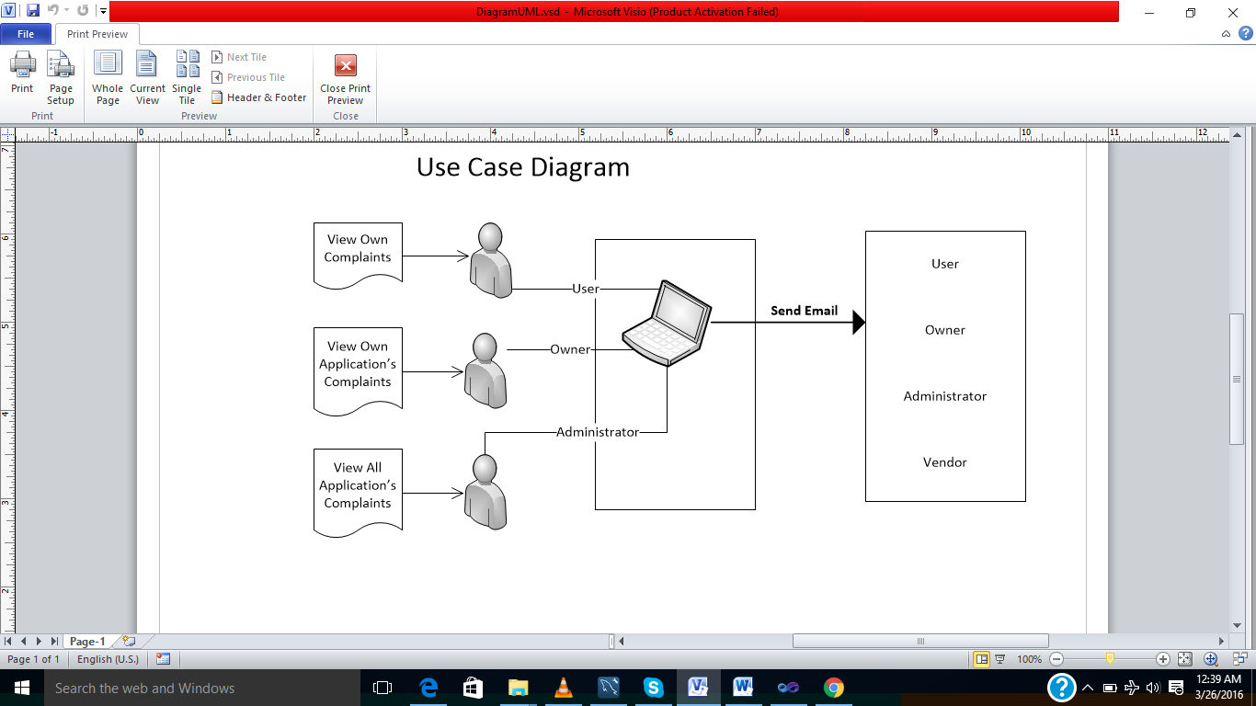

***1.4 User Complaint Registration Screen***

* User can register complaint from the following screen with attached screen shot

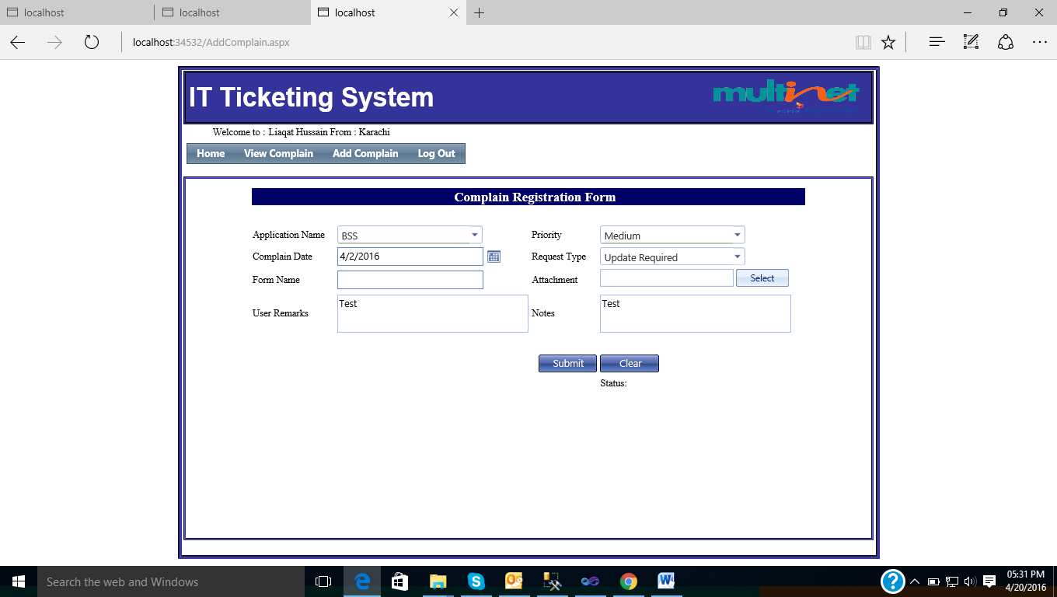

***1.5 User Complaint View***

* User can view his own complaints, screen shot given bellow

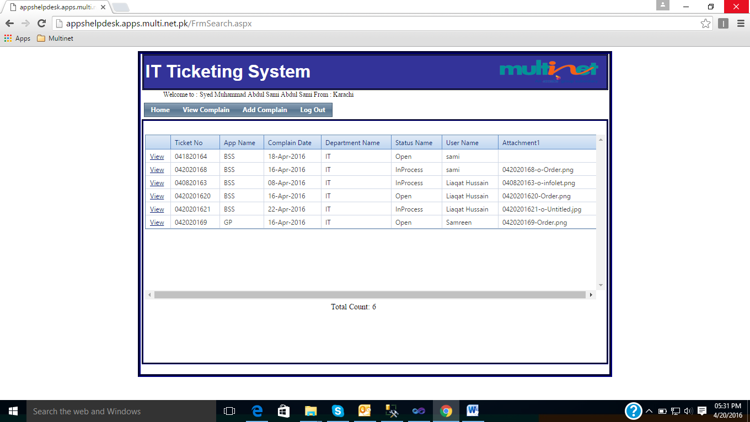

**1.6 User can view complaint Status**

* User can re-open the complaint and update the remarks

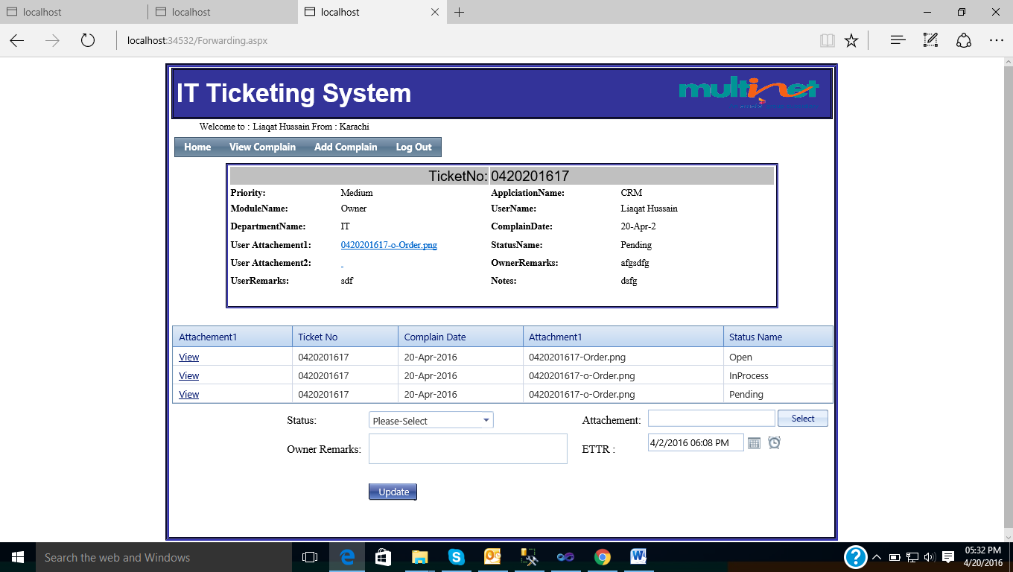

**1.7 Application Owner View Complaints**

* Application Owner can view his own Application complaint at the following screen



**1.8 Application Owner can view Status**

* Application Owner can update the complaint Status, Resolution time and attachment



**1.9 Administrator can view All Complaints**

* Administrator can view all complaints



**2.0 Administrator can update status**

* Administrator can update the status, resolution Time, attachment and forward the email to any one developer and vendor

